**BASIS DATA**

**TUGAS PRAKTIKUM UJIAN TENGAH SEMESTER GANJIL 2019 /2020**

**NAMA : ADE LITA**

**NIM : 20180801317**

**PRODY : TEKNIK INFOMATIKA**

**SOAL** :

1. Perhatikan Diagram dibawah ini :

|  |
| --- |
| Customer |
| Cus ID |
| First Name |
| Middle Name |
| Last Name |
| Shipping Address |
| Email |
| Contact |

|  |
| --- |
| Product |
| Product ID |
| Product Name |
| Category |
| Buy Price |
| Sell Price |
| Product Image |
| Description |

|  |
| --- |
| Order |
| Order No |
| Customer |
| Date |
| Is Deliver |

|  |
| --- |
| Employee |
| Emp ID |
| First Name |
| Middle Name |
| Last Name |
| Father Name |
| Mother Name |
| Email |
| Gender |
| Date of Birth |
| Marital Status |
| Address |

|  |
| --- |
| Login |
| User ID |
| Password |
| Access Level |

|  |
| --- |
| Payment |
| Payment No |
| Payment Type |
| Date |
| Amount |

|  |
| --- |
| Stock |
| Product Name |
| Quantity |
| Date |
| Stock By |

|  |
| --- |
| Order Details |
| Order No |
| Product Name |
| Quantity |

|  |
| --- |
| Shipment |
| Shipment Address |
| Shipment Date |
| Note |
| Shipment Contact |

Dari Diagram online shop diatas, buatlah :

1. Entity Diagram
2. Tentukan hubungan antar entity
3. Tentukan Primary Key dan Foreign Key yang dibutuhkan
4. Create Table
5. Insert Data (bebas) untuk semua table
6. Tampilkan data transaksi
7. Tampilkan produk terbanyak dijual
8. Tampilkan presentasi penjualan tiap hari untuk masing-masing produk

**ENTITY DIAGRAM**

|  |
| --- |
| Customer |
| Cus ID |
| First Name |
| Middle Name |
| Last Name |
| Shipping Address |
| Email |
| Contact |

|  |
| --- |
| Product |
| Product ID |
| Product Name |
| Category |
| Buy Price |
| Sell Price |
| Product Image |
| Description |

|  |
| --- |
| Order |
| Order No |
| Customer |
| Date |
| Is Deliver |

|  |
| --- |
| Employee |
| Emp ID |
| First Name |
| Middle Name |
| Last Name |
| Father Name |
| Mother Name |
| Email |
| Gender |
| Date of Birth |
| Marital Status |
| Address |

|  |
| --- |
| Login |
| User ID |
| Password |
| Access Level |

|  |
| --- |
| Payment |
| Payment No |
| Payment Type |
| Date |
| Amount |

|  |
| --- |
| Stock |
| Product Name |
| Quantity |
| Date |
| Stock By |

|  |
| --- |
| Order Details |
| Order No |
| Product Name |
| Quantity |

|  |
| --- |
| Shipment |
| Shipment Address |
| Shipment Date |
| Note |
| Shipment Contact |

**HUBUNGAN ANTAR ENTITY**

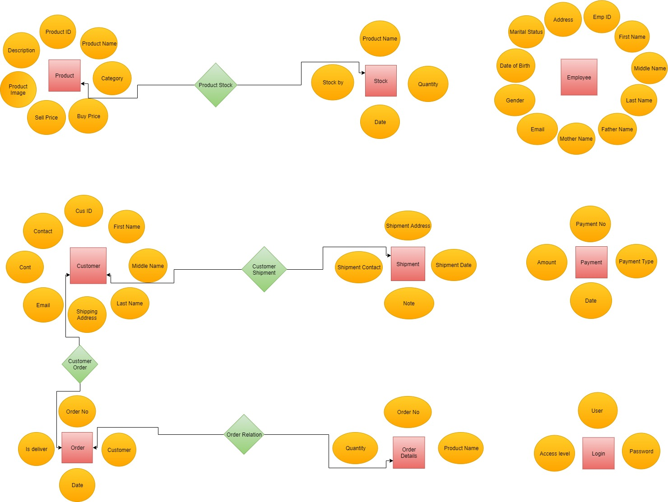

**PRIMERY KEY DAN FOREIGN KEY**

|  |
| --- |
| Product |
| Product ID (PK) |
| Product Name |
| Category |
| Buy Price |
| Sell Price |
| Product Image |
| Description |

|  |
| --- |
| Customer |
| Cus ID (PK) |
| First Name |
| Middle Name |
| Last Name |
| Shipping Address |
| Email |
| Contact |

|  |
| --- |
| Order |
| Order No (PK) |
| Customer (FK) |
| Date |
| Is Deliver |

|  |
| --- |
| Stock |
| Product Name (FK) |
| Quantity |
| Date |
| Stock By |

|  |
| --- |
| Order Details |
| Order No (FK) |
| Product Name (FK) |
| Quantity |

CREATE TABLE "ADE_PRODUCT"

( "PRODUCT_ID" NUMBER,

"PRODUCT_NAME" VARCHAR2(50),

"CATEGORY" VARCHAR2(25),

"BUY_PRICE" NUMBER NOT NULL ENABLE,

"SELL_PRICE" NUMBER NOT NULL ENABLE,

"PRODUC_IMAGE" VARCHAR2(50),

"DESCRIPTION" VARCHAR2(50),

CONSTRAINT "ADE_PRODUCT_PK" PRIMARY KEY ("PRODUCT_ID") ENABLE

)

/

DESC ADE_PRODUCT

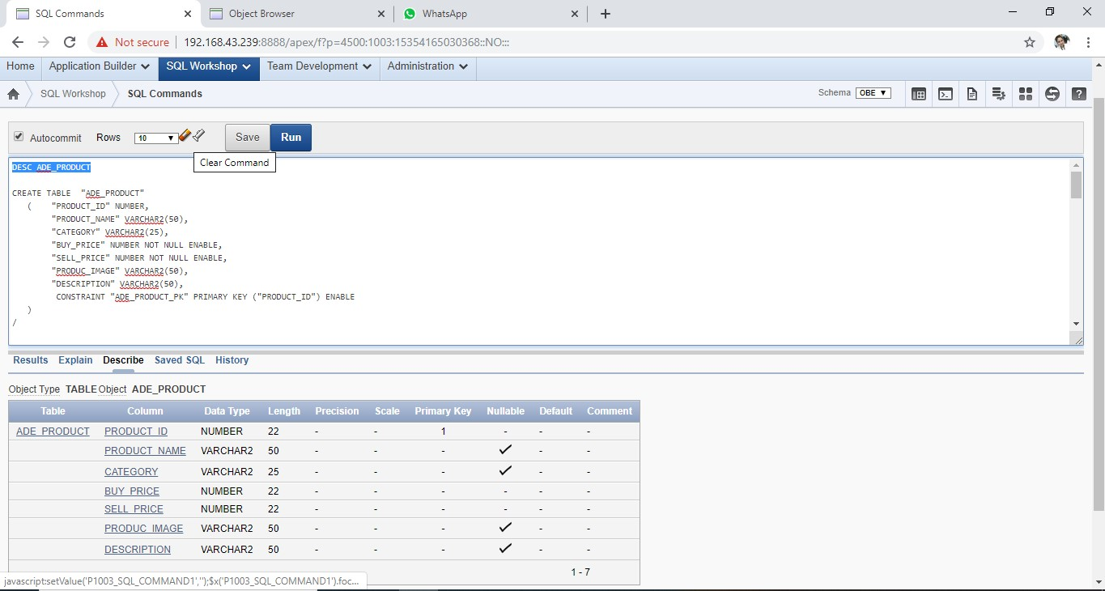

==================================================================================

CREATE TABLE "ADE_CUSTOMER"

( "CUS_ID" NUMBER,

"FIRST_NAME" VARCHAR2(25) NOT NULL ENABLE,

"MIDDLE_NAME" VARCHAR2(25),

"LAST_NAME" VARCHAR2(25),

"SHIPPING_ADDRESS" VARCHAR2(50) NOT NULL ENABLE,

"EMAIL" VARCHAR2(25),

"CONTACT" NUMBER,

CONSTRAINT "ADE_CUSTOMER_PK" PRIMARY KEY ("CUS_ID") ENABLE

)

/

DESC ADE_CUSTOMER

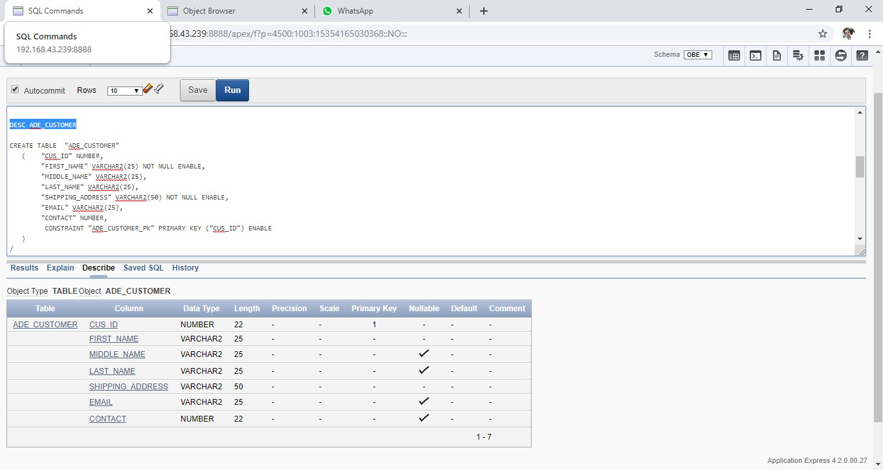

==================================================================================

CREATE TABLE "ADE_ORDER"

( "ORDER_NO" NUMBER,

"CUSTOMER" NUMBER,

"DATES" DATE,

"IS_DELIVER" VARCHAR2(25),

CONSTRAINT "ORDERS_PK" PRIMARY KEY ("ORDER_NO") ENABLE

)

/

DESC ADE_ORDER

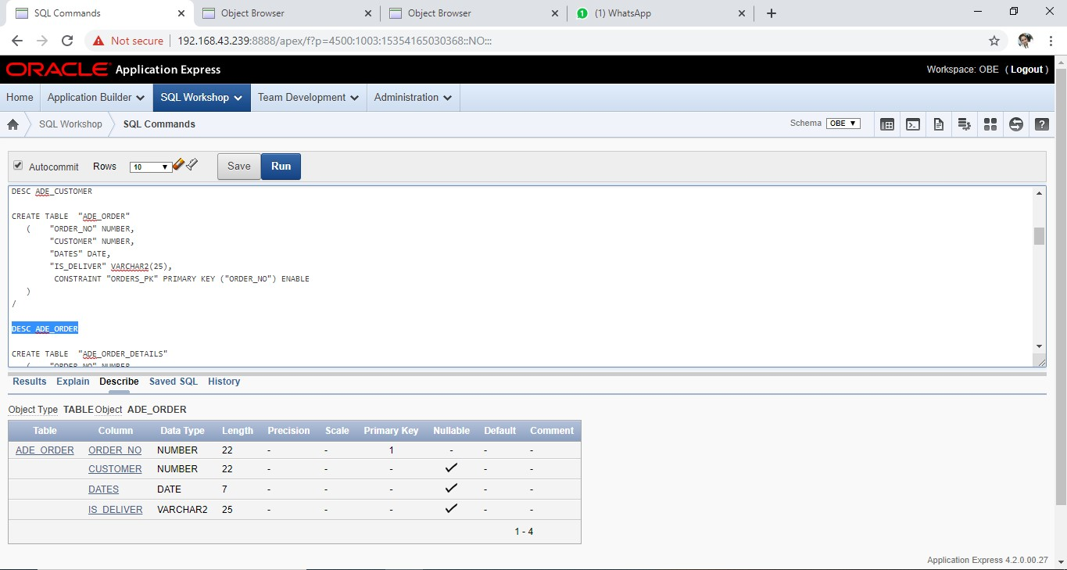

==================================================================================

CREATE TABLE "ADE_ORDER_DETAILS"

( "ORDER_NO" NUMBER,

"PRODUCT_NAME" NUMBER,

"QUANTITY" NUMBER

)

/

DESC ADE_ORDER_DETAILS

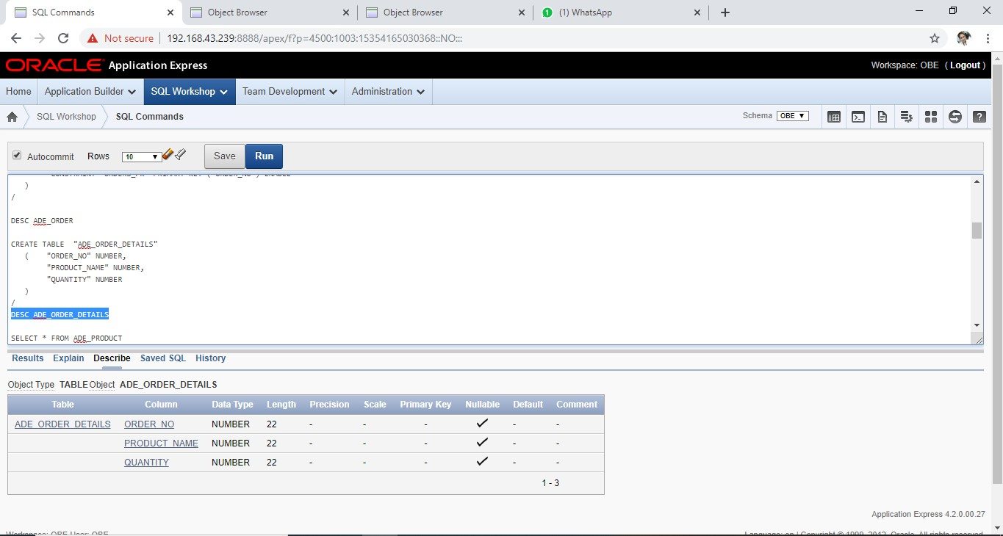

==================================================================================

SELECT * FROM ADE_PRODUCT

INSERT ADE_PRODUCT

VALUES ('123','SAPU','ALAT KEBERSIHAN','25000','35000','','')

INSERT ADE_PRODUCT

VALUES ('124','PELAN','ALAT KEBERSIHAN','45000','60000','','')

INSERT ADE_PRODUCT

VALUES ('125','KEMOCENG','ALAT KEBERSIHAN','20000','25000','','')

INSERT ADE_PRODUCT

VALUES ('126','EMBER','ALAT KEBERSIHAN','10000','20000','','')

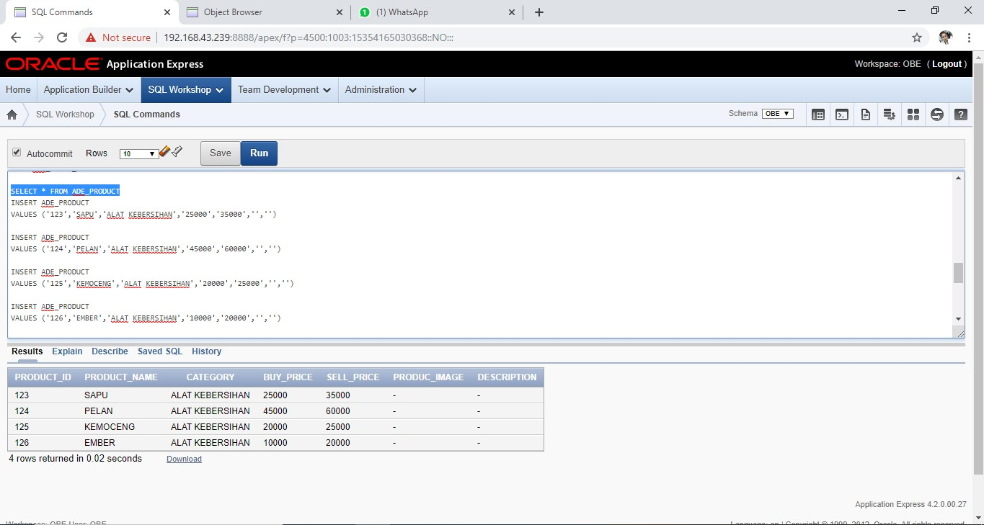

==================================================================================

SELECT * FROM ADE_CUSTOMER

INSERT ADE_CUSTOMER

VALUES ('111','ADE','','LITA','PERUM GRIYA PERMAI','LITAADE5@GMAIL.COM','085213009529')

INSERT ADE_CUSTOMER

VALUES ('112','NABILA','IZZATUN','NISA','KOTA

MALANG','NABILANISA@GMAIL.COM','085222376895')

INSERT ADE_CUSTOMER

VALUES ('113','SELENA','','LESTARI','KANDANGHAUR','SELENA002@GMAIL.COM','089977730065')

INSERT ADE_CUSTOMER

VALUES ('114','NAFISA','ZURIAH','RAHMA','MALANG KOTA','ZURIAHRAHMA@GMAIL.COM','085222008547')

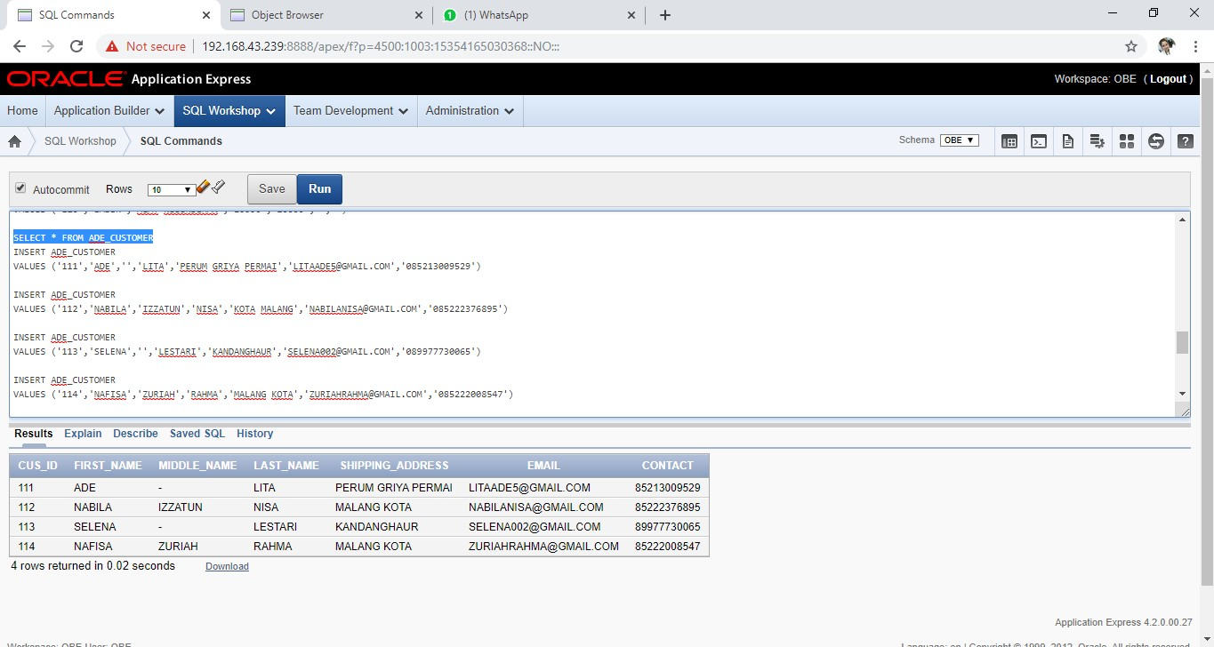

==================================================================================

SELECT * FROM ADE_ORDER

INSERT ADE_ORDER

VALUES ('997','111','09/11/2019','DELIVER')

INSERT ADE_ORDER

VALUES ('998','112','06/11/2019','DELIVER')

INSERT ADE_ORDER

VALUES ('999','113','01/11/2019','DELIVER')

INSERT ADE_ORDER

VALUES ('1000','114','12/11/2019','DELIVER')

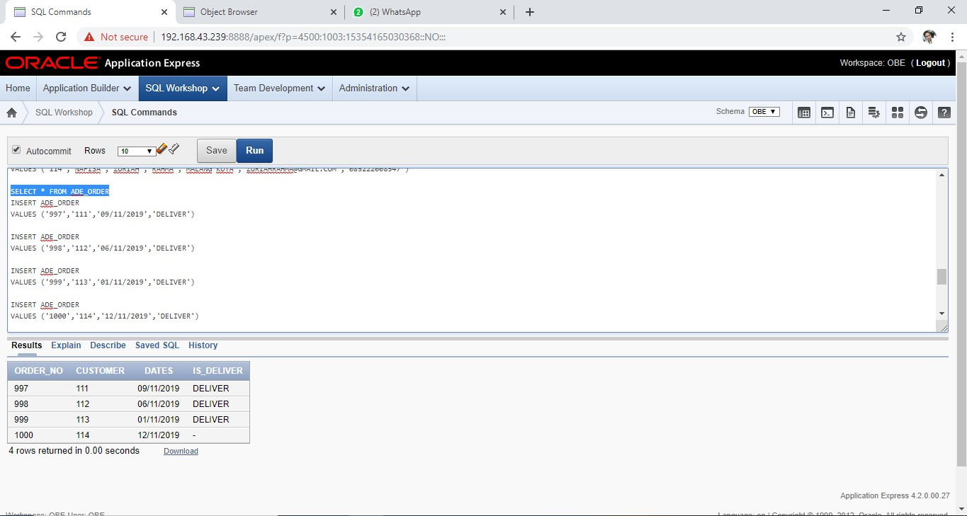

==================================================================================

SELECT * FROM ADE_ORDER_DETAILS

INSERT ADE_ORDER

VALUES ('998','125','3')

INSERT ADE_ORDER

VALUES ('999','126','6')

INSERT ADE_ORDER

VALUES ('1000','124','10')

INSERT ADE_ORDER_DETAILS

VALUES ('997','123','5')

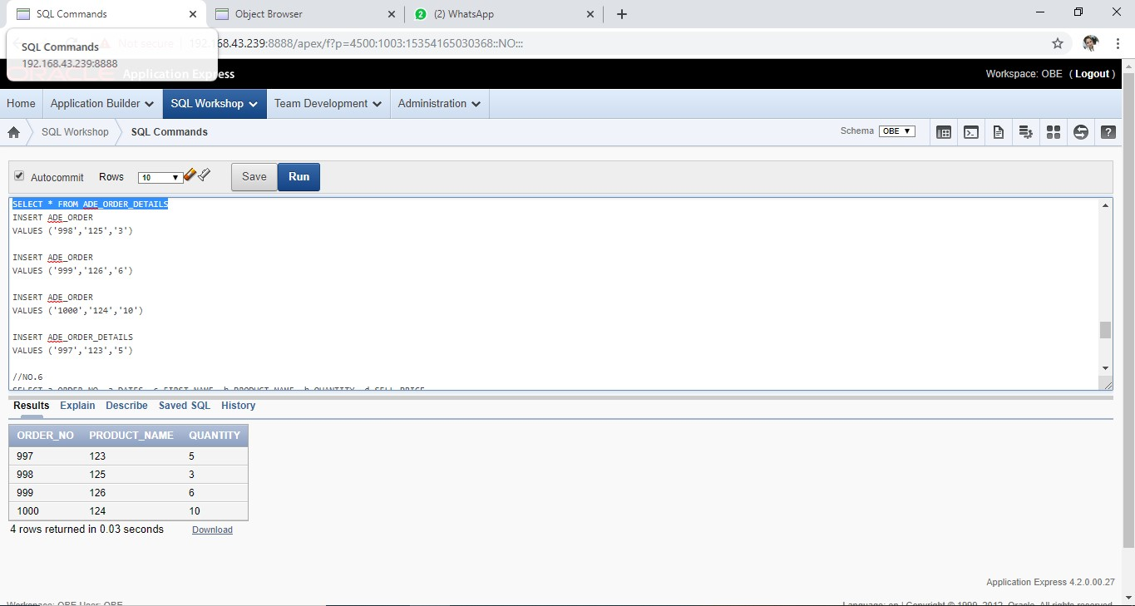

~~~~~~~~~~~~~~~~~~~~~~~~~~~~~~~~~~~~~~~~~~~~~~~~~~~~~~~~~~~~~~~~~~~~~~~~~~~~~~~~~~

//NO.6

SELECT a.ORDER_NO, a.DATES, c.FIRST_NAME, b.PRODUCT_NAME, b.QUANTITY, d.SELL_PRICE,

b.QUANTITY*d.SELL_PRICE as total

FROM ADE_ORDER a, ADE_ORDER_DETAILS b, ADE_CUSTOMER c, ADE_PRODUCT d

WHERE b.ORDER_NO = a.ORDER_NO and c.CUS_ID = a.CUSTOMER and b.PRODUCT_NAME = d.PRODUCT_ID

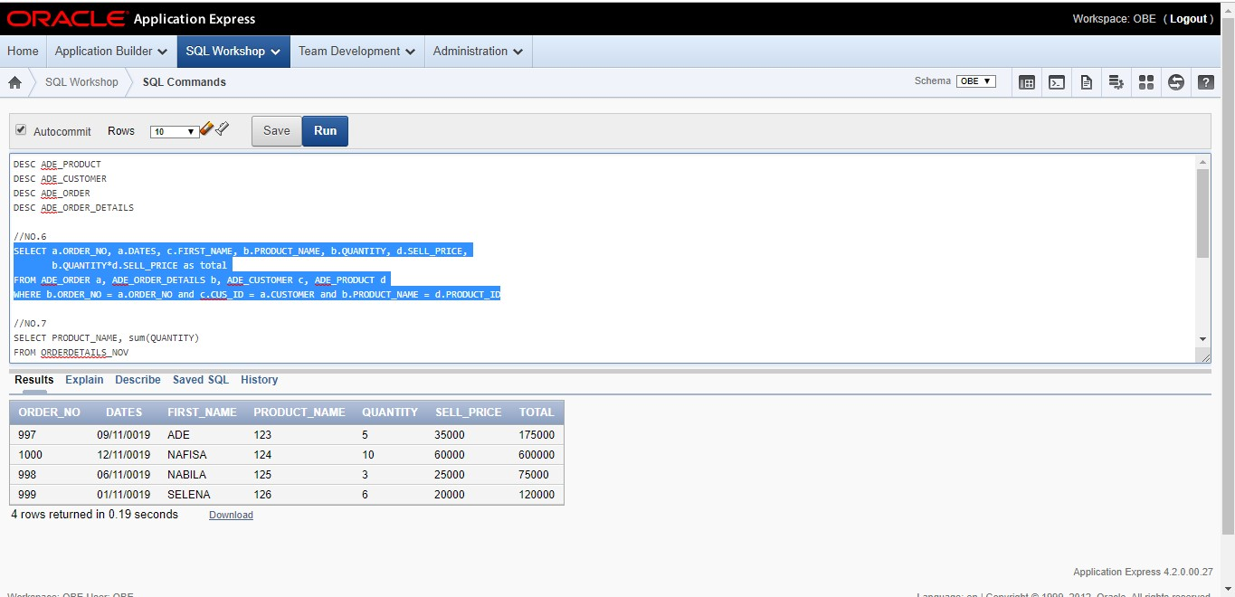

~~~~~~~~~~~~~~~~~~~~~~~~~~~~~~~~~~~~~~~~~~~~~~~~~~~~~~~~~~~~~~~~~~~~~~~~~~~~~~~~~~

//NO.7

SELECT PRODUCT_NAME, sum(QUANTITY)

FROM ADE_ORDER_DETAILS

GROUP by PRODUCT_NAME, QUANTITY

ORDER by quantity desc

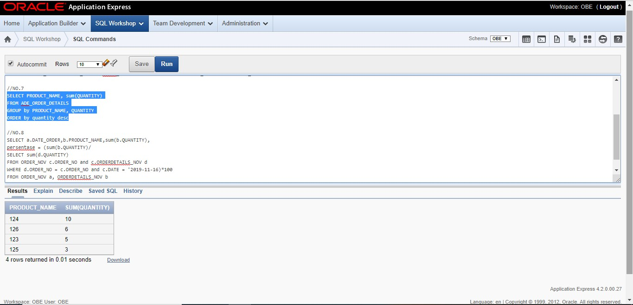

~~~~~~~~~~~~~~~~~~~~~~~~~~~~~~~~~~~~~~~~~~~~~~~~~~~~~~~~~~~~~~~~~~~~~~~~~~~~~~~~~~

//NO.8

SELECT a.PRODUCT_NAME, SUM(a.QUANTITY),

ROUND((SUM(a.QUANTITY)/(SELECT SUM(c.QUANTITY) FROM ADE_ORDER_DETAILS c, ADE_ORDER d WHERE d.ORDER_NO = c.ORDER_NO and d.DATES= '12/11/2019'))*100) AS Prosentase

FROM ADE_ORDER_DETAILS a, ADE_ORDER b

WHERE b.ORDER_NO = a.ORDER_NO and b.DATES= '12/11/2019'

GROUP BY b.DATES, a.PRODUCT_NAME, a.QUANTITY

